Project Development Phase
Model Performance Test
Date | 28 September 2026
Team ID | 6ab221d587602313e82c60c9
Project Name | Project - Import Data using Transform Maps (Spreadsheet)
Maximum Marks

Model Performance Testing:
Project team shall fill the following information in model performance testing template.
S.No. | Parameter | Screenshot / Values
1. | Data Rendered | Employee data received as a spreadsheet (.xlsx/.csv) was uploaded into ServiceNow via System Import Sets > Load Data, creating a staging (import set) table.  [Screenshot: Load Data page and imported rows in the staging table]  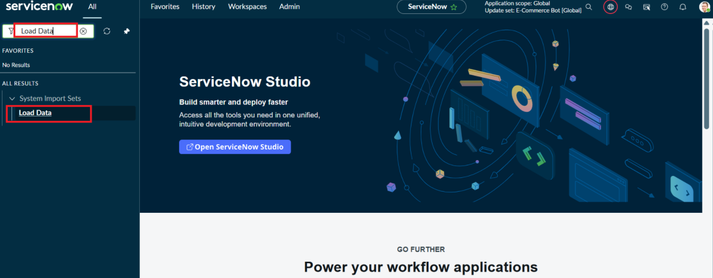  Application Navigator → System Import Sets → Load Data  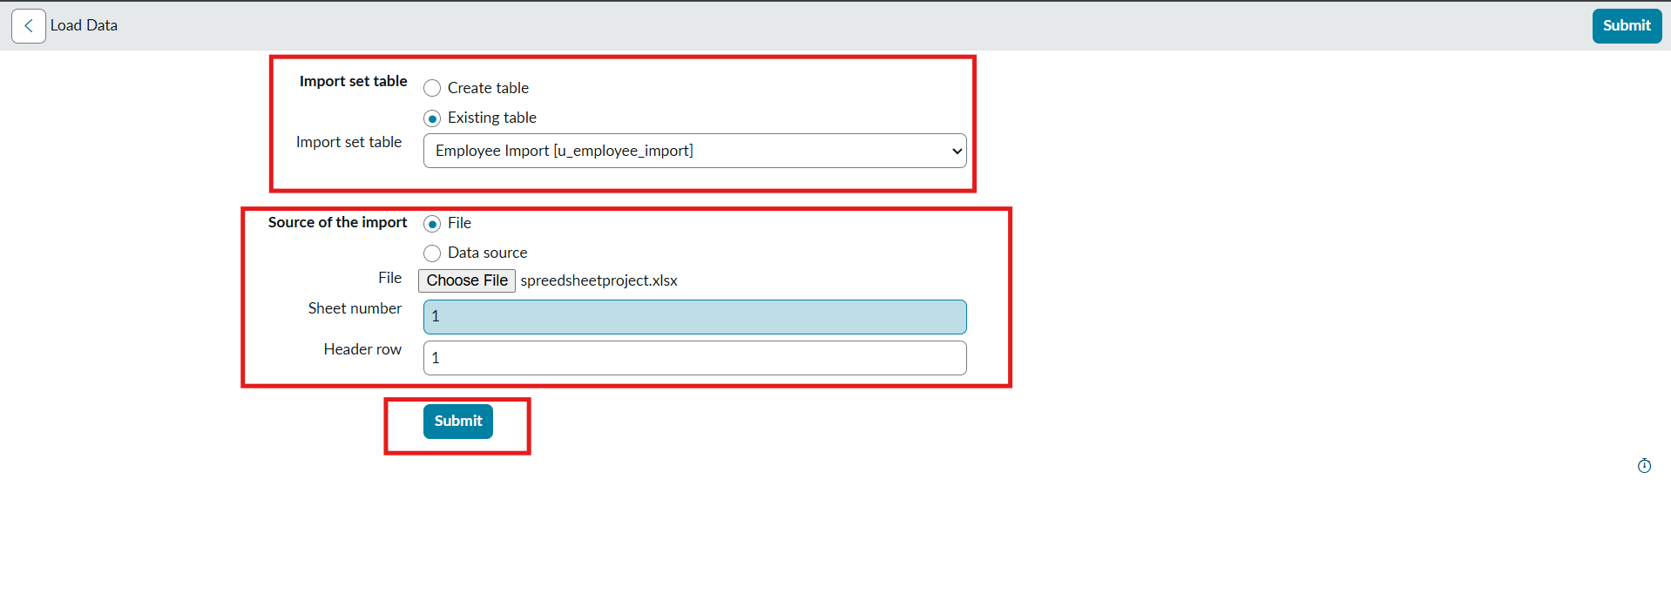  Load Data form: Employee Import table, spreadsheetproject.xlsx    Data loaded into staging table: Complete – Processed 4, errors 0
2. | Data Preprocessing | Spreadsheet columns were checked for blanks, duplicates and format issues before loading; the import set rows were reviewed and column-to-field mappings were prepared in the Transform Map.  [Screenshot: Import Set rows / Table Transform Map field mappings]  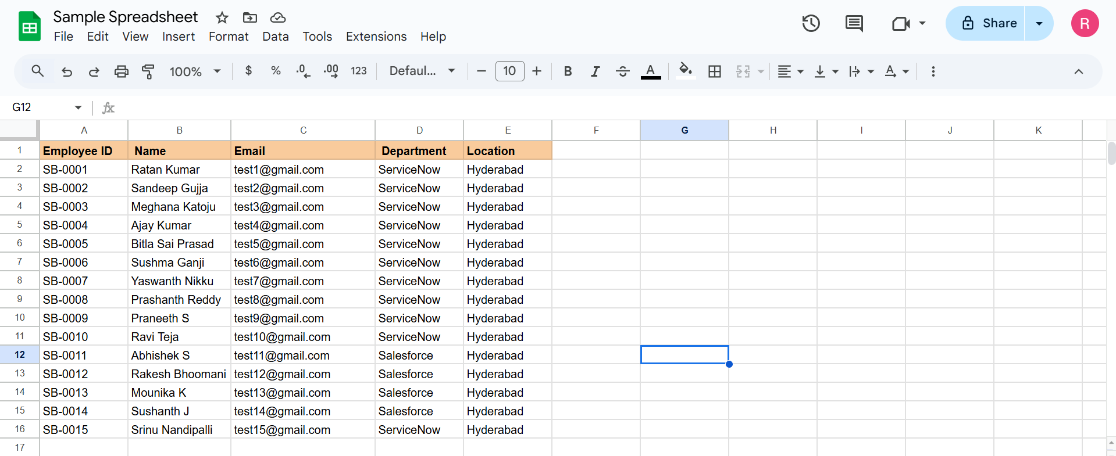  Source spreadsheet data (Employee ID, Name, Email, Department, Location)  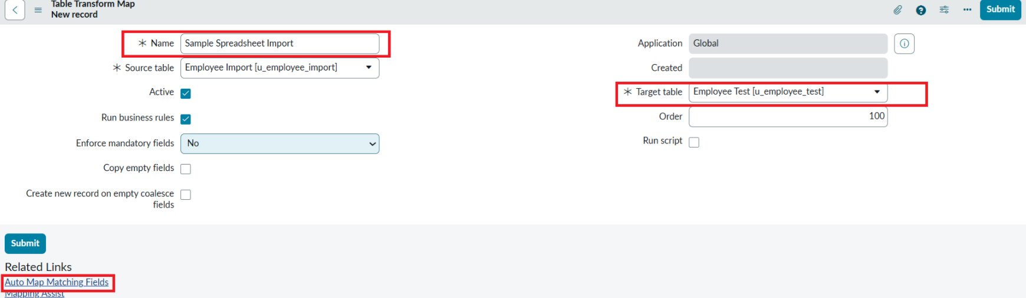  Table Transform Map: Employee Import → Employee Test    Field mappings: source fields to target fields
3. | Utilization of Data Filters | Coalesce on a unique field (e.g. Employee ID / Email) was used to avoid duplicate records, and a Transform Map script / field map conditions were used to skip invalid rows.  [Screenshot: Coalesce setting and Transform Map script]    Coalesce = true on Employee ID field map    Re-import of same data: Inserts 0, Updates 0, Ignored 4 (no duplicates)
4. | DAX Queries Used | Not applicable – ServiceNow Transform Maps were used instead of DAX. Field maps and Transform Scripts (onBefore) handled data conversion.  [Screenshot: Transform Map field maps / scripts]  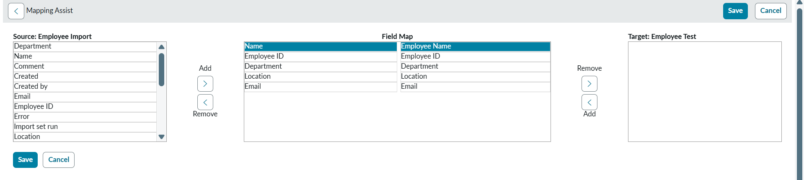  Mapping Assist: Source vs Target fields  Transform Map field maps
5. | Dashboard design | No of Visualizations / Graphs -  [Screenshot: Transform history / target table list view showing imported records]  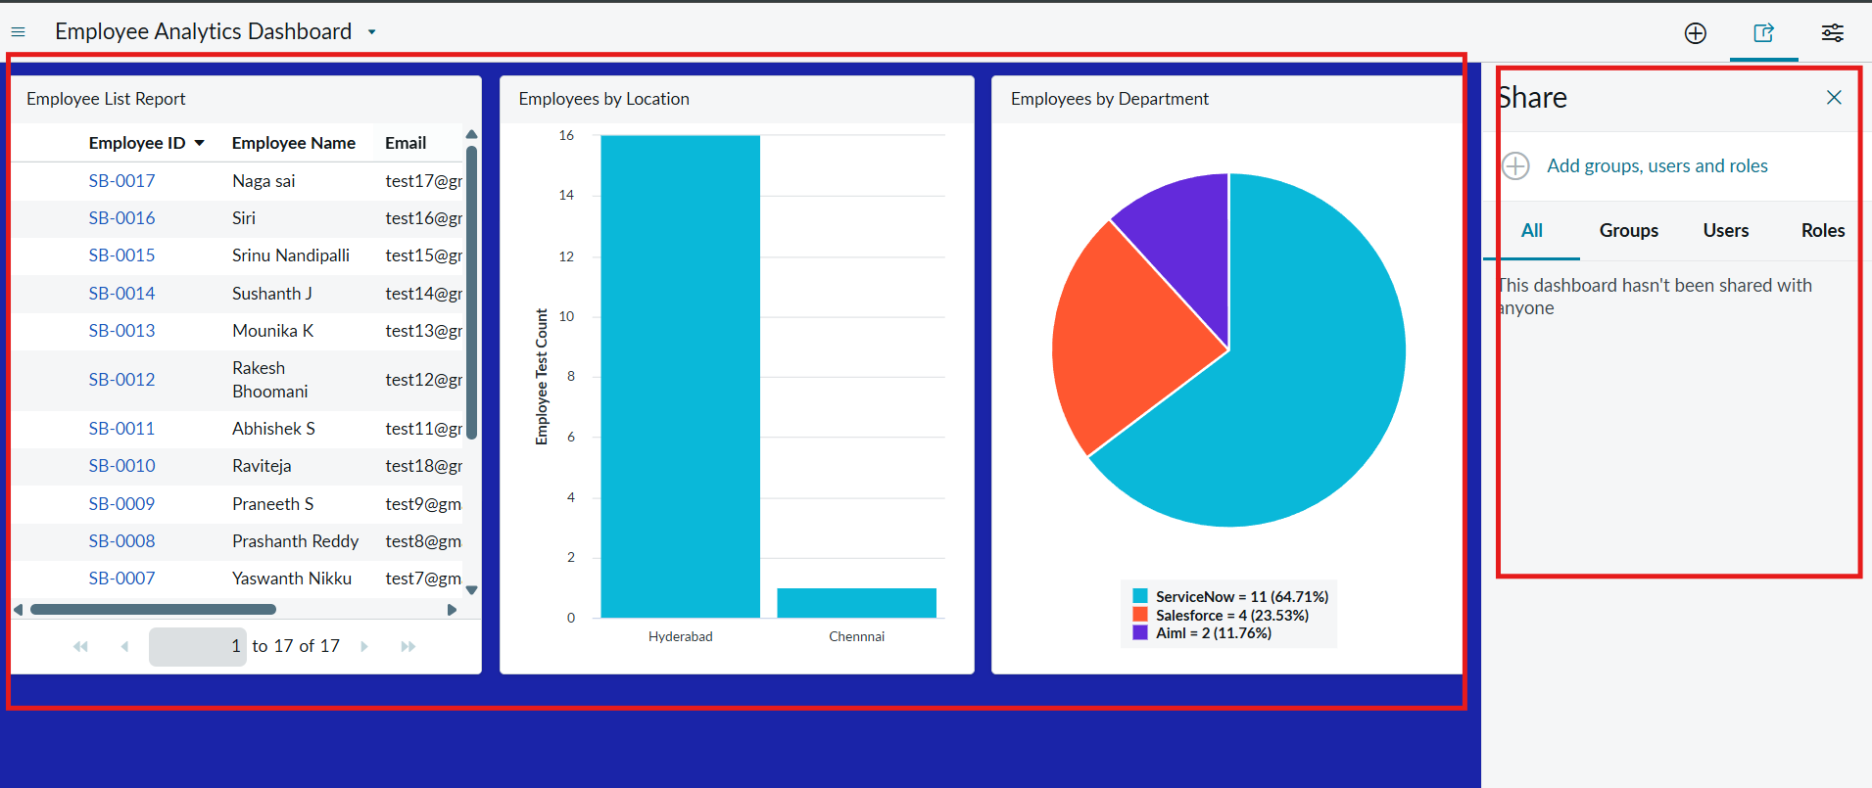  Employee Analytics Dashboard with 3 report widgets    Transform History: Total 4, Inserts 2, Updates 2    Employee Test table list view showing imported records
6. | Report Design | No of Visualizations / Graphs -  [Screenshot: Report of imported records in the target table]  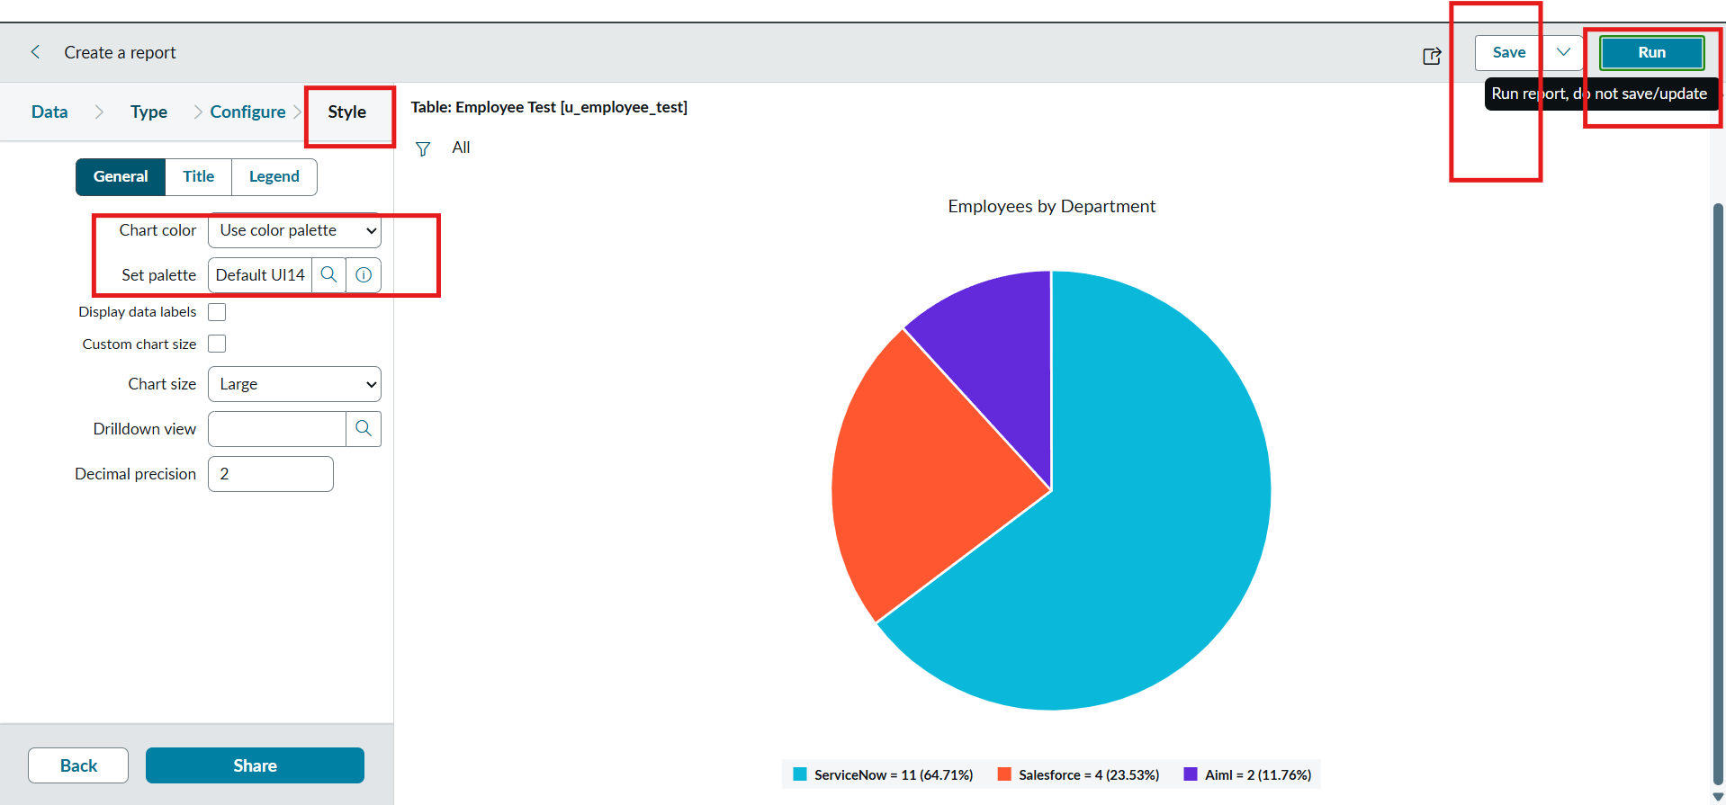  Report 1 – Employees by Department (Pie chart)  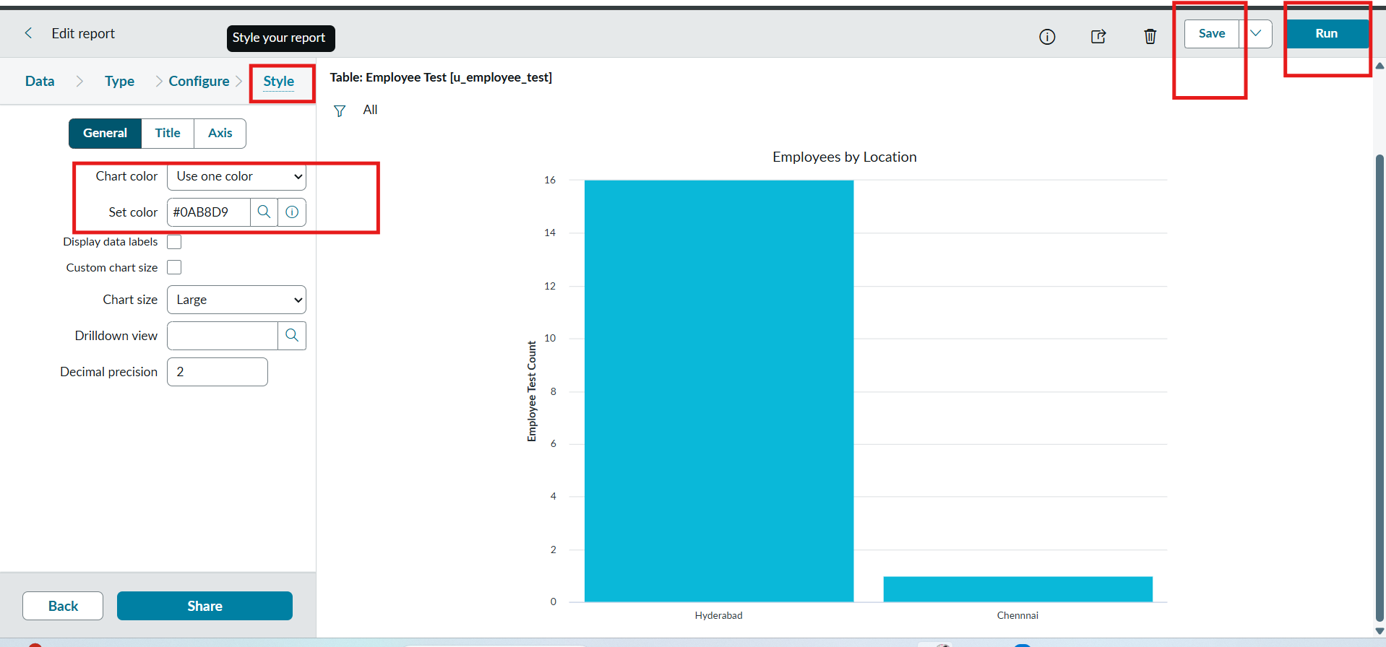  Report 2 – Employees by Location (Bar chart)  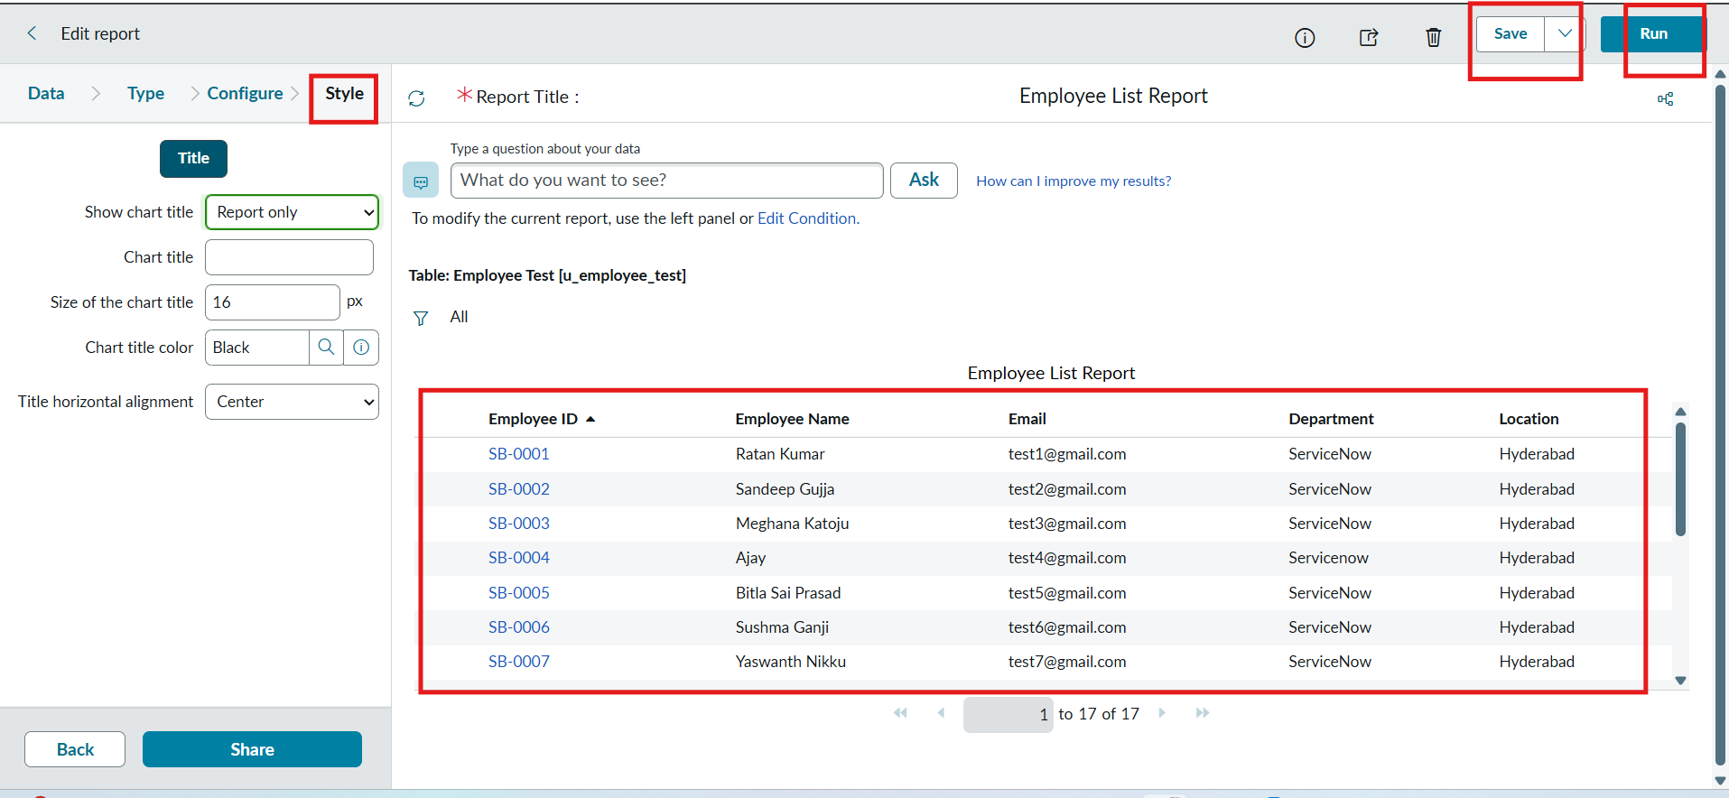  Report 3 – Employee List Report (List)

